1. Perform a spectral analysis on the data found in file mod11_spectral_analysis_data.mat. Create an m-file named "spectral_analysis_LastName.m" that uses the FFT to compute the spectrum of the signal. Plot out the spectrum both in terms of its raw magnitude and in dB relative to the peak value. Use the "text" command to annotate the dB plot to indicate the main and secondary peaks. Also, indicate the level of the secondary peaks (in dB) relative to the main peak. Note: in the data file, 'fs' is the sampling rate in units of samples-per-second; 't' is the time vector in units of seconds; and 's' is the sampled data signal.

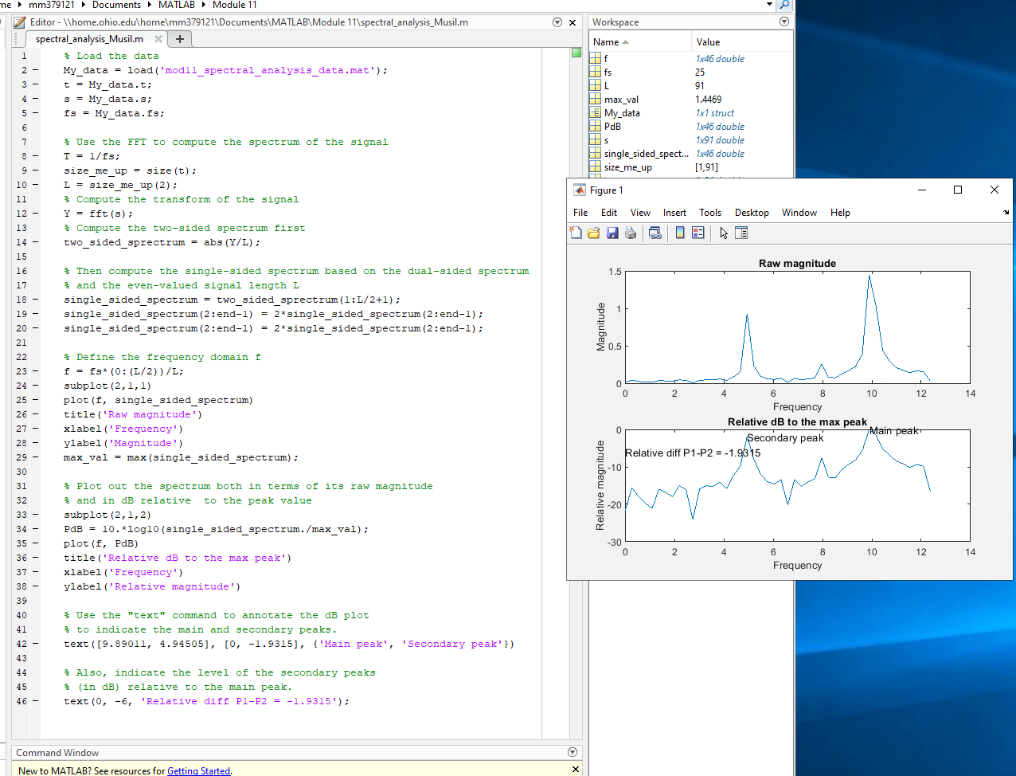

1. Download BodePlot1.m. Copy lines 78 through the end of the m file. Call the new file "BodePlotHomework_LastName.m". Modify the code to plot a Bode plot for the function:

